* Below is the home page for the personal website. Need to change the background photo.

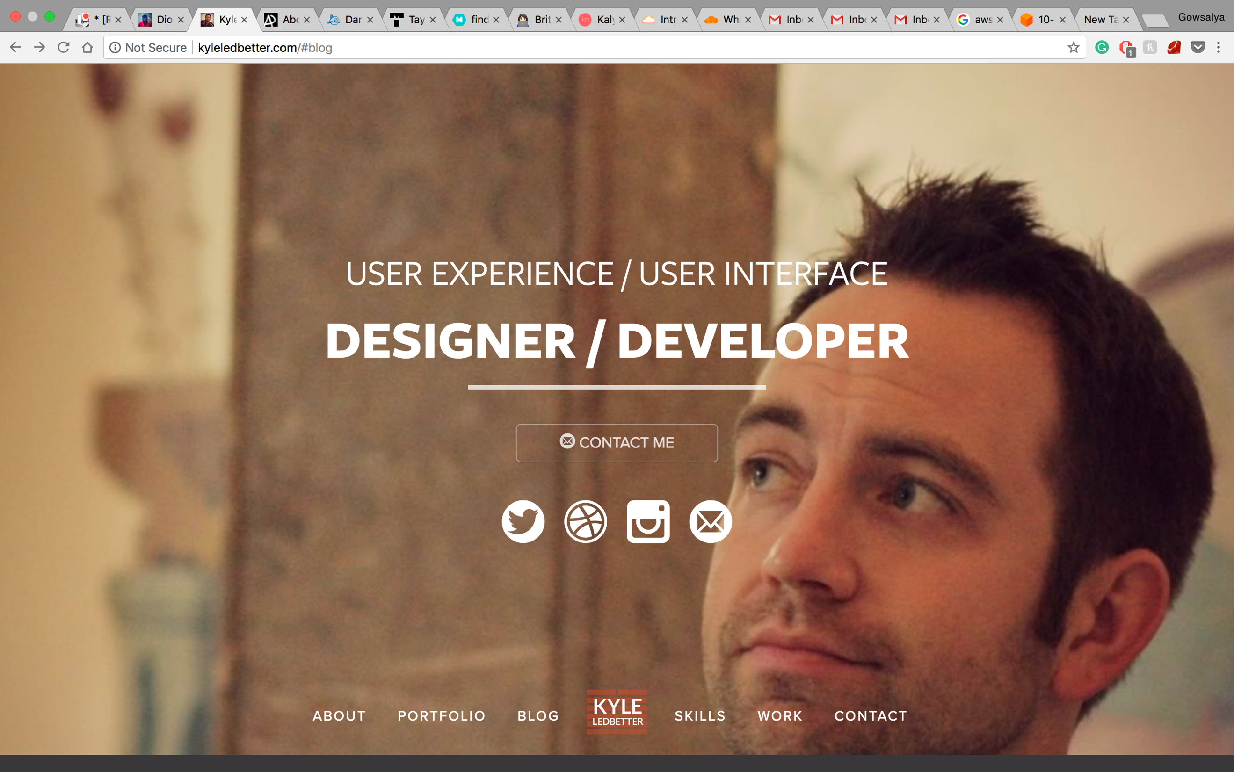

* About page – (1) Give 1 or 2 line below “About”

(2) Give the area of expertise in the hexagon boxes.

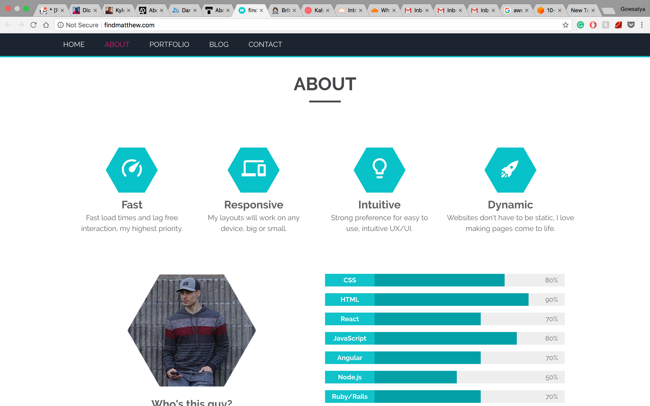

* Provide the skillset like the below

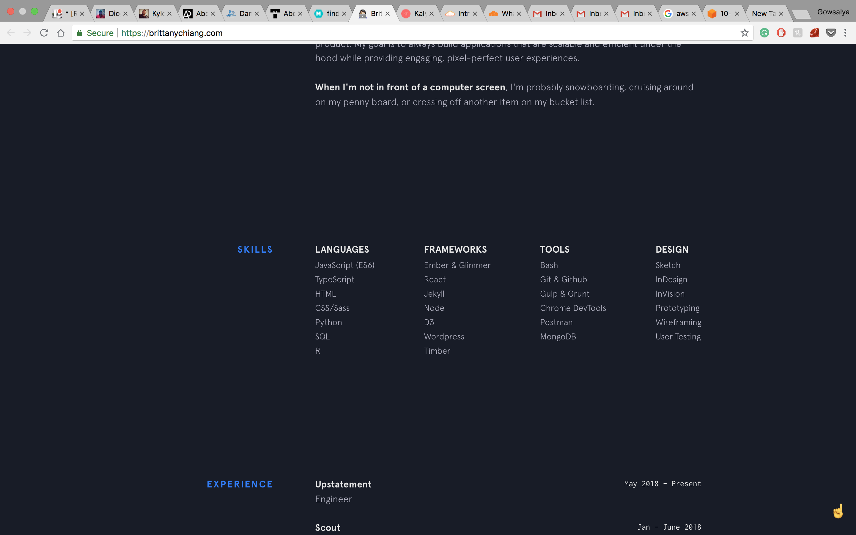

* Provide the project like the below format

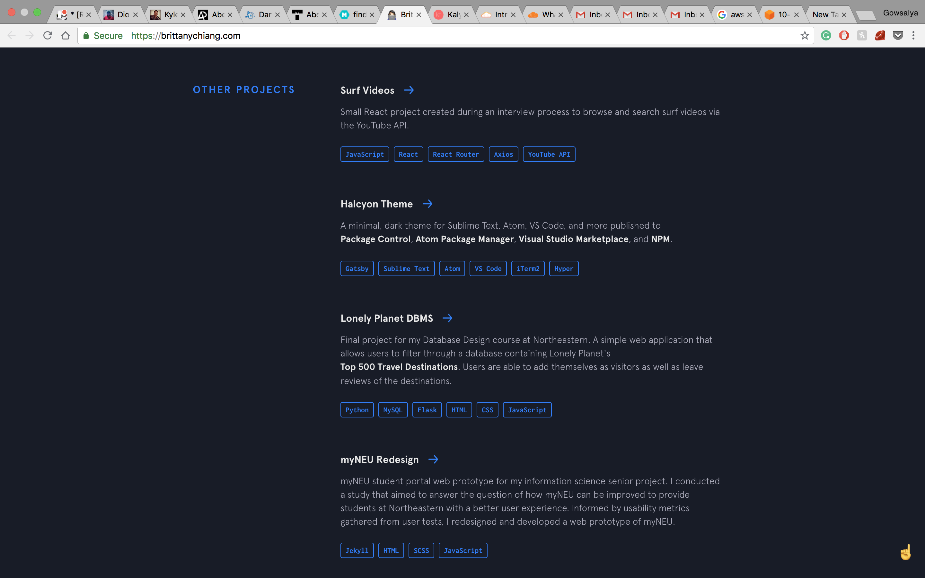

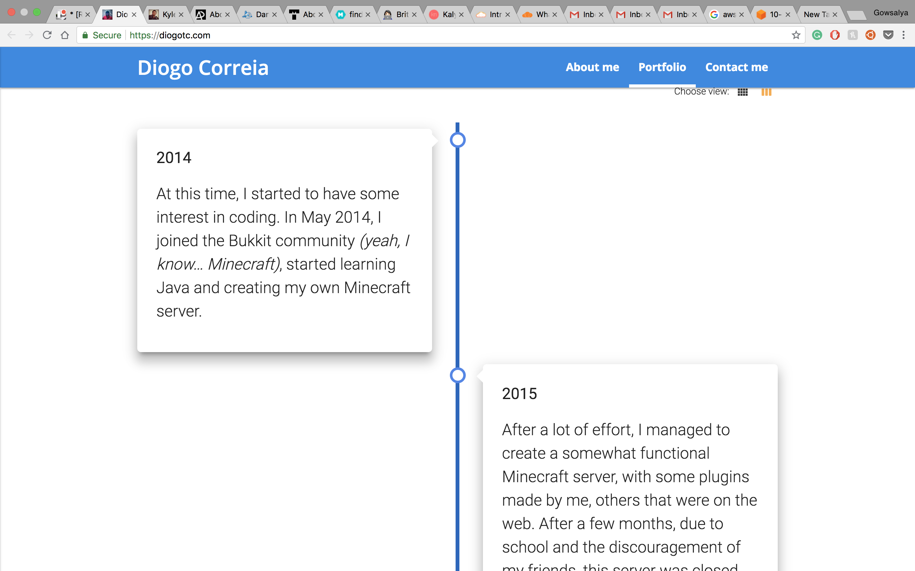

* Academic projects

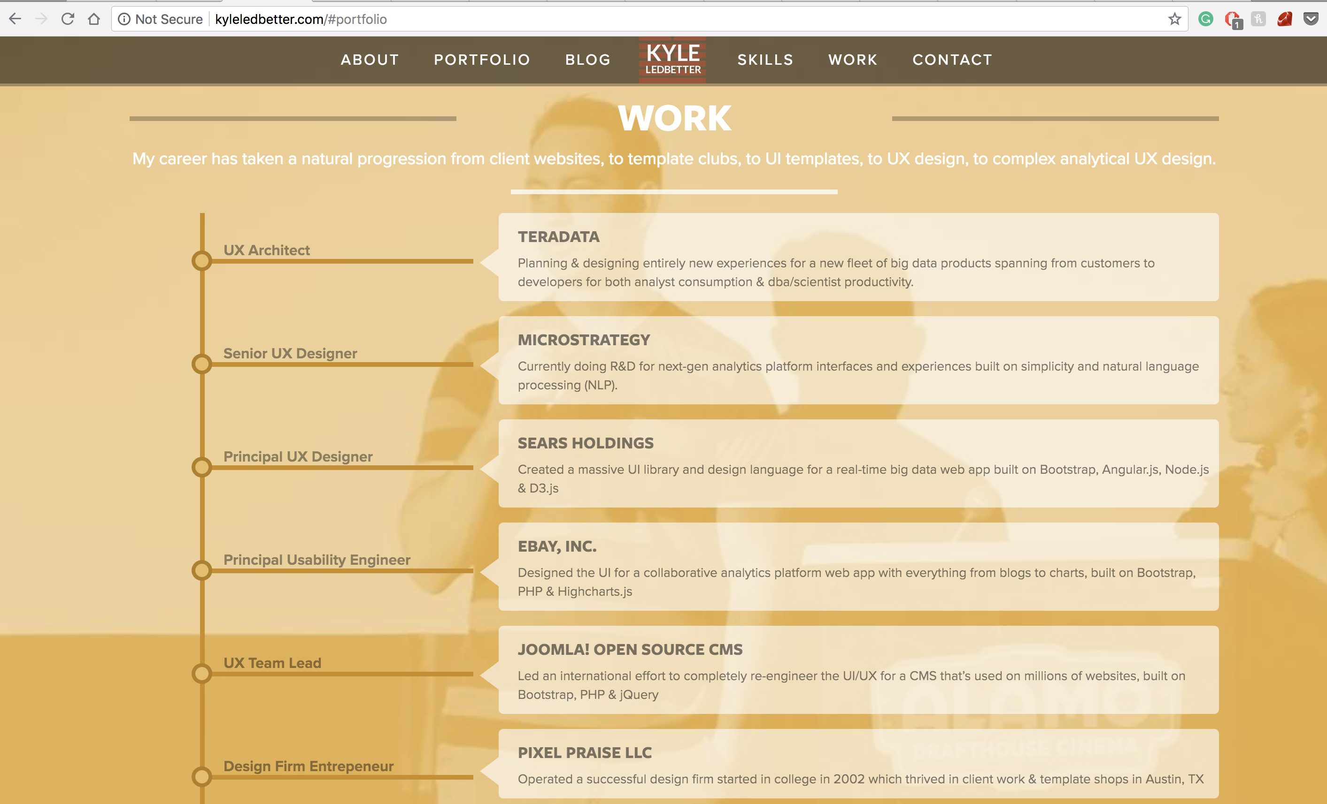

Contact Me:



Reference:

<https://brittanychiang.com/>

<http://kalynnakano.com/>

<http://findmatthew.com/>

<https://www.taylormccaslin.com/>

<http://www.danzhang.net/>

<http://rogergzou.com/>

<https://andrewborstein.com/>

<http://www.adhamdannaway.com/about>

<http://kyleledbetter.com/>

<https://diogotc.com/>